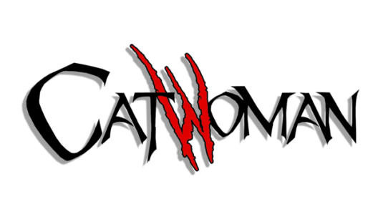

Catwoman [Volume 1]

Issues: 4
Date: February - May 1989

Collected edition:

- Catwoman: Her Sister’s Keeper.

Catwoman [Volume 2]

Issues: 94
Date: August 1993 - July 2001

This run also includes:

- #0 (1994);
- #1,000,000 (1998) (Collected in DC One Million Omnibus);
- 4 Annuals (1994-1997);
- Catwoman/Vampirella: The Furies (graphic novel, 1997);
- Catwoman/Wildcat #1-4 (mini-series, August-November 1998).

Collected editions:

Only one Catwoman trade paperback has been published of this volume:

- Catwoman: The Catfile (#15-19).

Certain issues of this volume (Vol. 2) have been collected in Batman trade paperbacks:

- #6-7 Batman: Knightfall (Vol. 2, NEW edition);
- #12 Batman: Knightfall (Vol. 3, OLD edition / Vol. 3, NEW edition);
- #13 Batman: Knightfall (Vol. 3, NEW edition);
- #31-32 Batman: Contagion;
- #35-36 Batman: Legacy;
- #56 Batman: Cataclysm (OLD edition / NEW edition);
- #57 Batman: Cataclysm (NEW edition)
- #72-74 Batman: No Man’s Land (Vol. 2 NEW edition);
- #75-77 Batman: No Man’s Land (Vol. 4 NEW edition);
- #90 Batman: Officer Down.

Catwoman [Volume 3]

Issues: 83
Date: January 2002 - October 2008/March 2010

- This series lasted for 82 issues until it was canceled; a little over a year later it was resurrected for a single issue (#83) as a tie-in to Blackest Night.

This run includes:

Catwoman: Secret Files & Origins #1 (2002).

Collected editions:

- Regular trade paperbacks:

- The Dark End of the Street (#1-4 , stories from Detective Comics #759-762*);
- Crooked Little Town (#5-10);
- Relentless (#12-19);
- Wild Ride (#20-24);
- The Replacements (#53-58);
- It's Only a Movie (#59-65);
- Catwoman Dies (#66-72);
- Crime Pays (#73-77);
- The Long Road Home (#78-82).

- Oversized trade paperbacks

- Vol. 1: Trail of the Catwoman
- (#1-9, Catwoman: Selina's Big Score and stories from Detective Comics #759-762*);
- Vol. 2: No Easy Way Down
- (#10-24 and Catwoman: Secret Files & Origins #1);
- Vol. 3: Under Pressure
- (#25-37);
- Vol. 4: The One You Love
- (38-49);
- Vol. 5: (TBA)
- ();

*: Detective Comics #759-762 featured the backup series "The Trial Of The Catwoman".

NOTES:
● #34-36 have been collected in Batman: War Games (#34 in Vol. 1, #35 in Vol. 2, #36 in Vol. 3);
● #34 has been collected in Batman: War Games Vol. 1 [NEW EDITION].

Catwoman [Volume 4]

- Part of The New 52.

