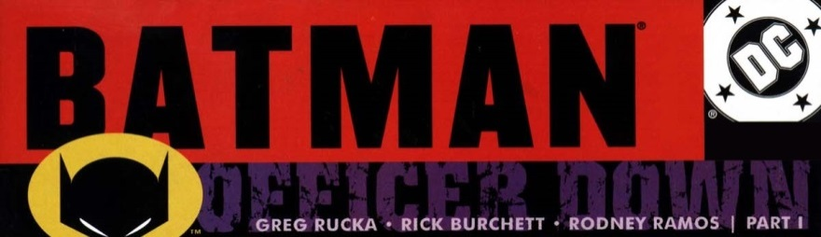
BATMAN: OFFICER DOWN [2001]
MAIN STORYLINE
- Batman #587 (Part 1);
- Robin (Vol. 4) #86 (Part 2);
- Birds Of Prey (Vol. 1) #27 (Part 3);
- Catwoman (Vol. 2) #90 (Part 4);
- Nightwing (Vol. 2) #53 (Part 5);
- Detective Comics #754 (Part 6);
- Batman: Gotham Knights #13 (Part 7).
TIE-IN:
- Batgirl (Vol. 1) #12 (takes place at the same time as part 2: Robin #86).

