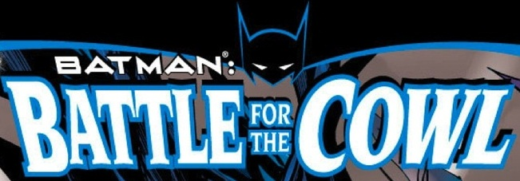

BATMAN: BATTLE FOR THE COWL [2009]

- Batman: Battle For The Cowl #1-3
- Battle For the Cowl: Commissioner Gordon #1
- Battle For The Cowl: Gotham Gazette: Batman Dead? #1
- Azrael: Death's Dark Knight #1-3 Collected in Azrael: Death’s Dark Knight
- Oracle: The Cure #1-3 Collected in Oracle: The Cure
- Battle For The Cowl: Arkham Asylum #1
- Battle For The Cowl: The Underground #1
- Battle For The Cowl: Man-Bat #1
- Battle For The Cowl: The Network #1
- Battle For The Cowl: Secret Six #9 Not collected
- Battle For The Cowl: Gotham Gazette: Batman Alive? #1

- RED = Collected in Batman: Battle For The Cowl
- BLUE = Collected in Batman: Battle For The Cowl Companion

