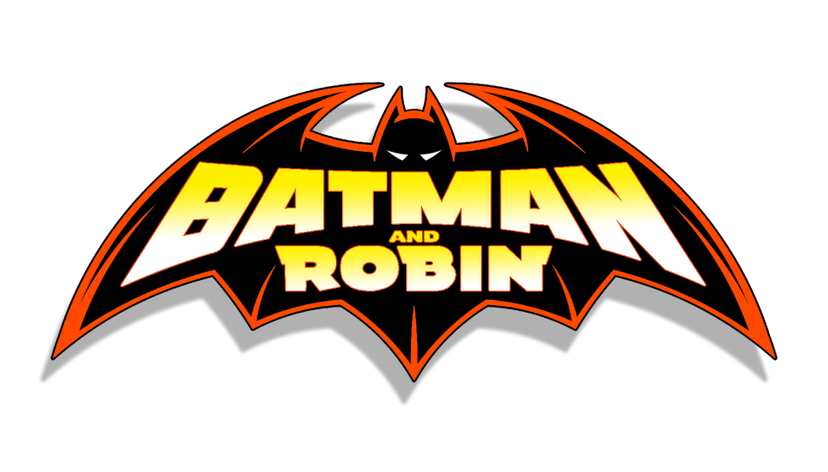

Batman & Robin [Volume 1]

- Features Dick Grayson as Batman and Damian Wayne as Robin.

Issues: 26
Date: August 2009 - October 2011

Collected editions:

- Vol. 1: Batman & Robin: Batman Reborn (#1-6);
- Vol. 2: Batman & Robin: Batman vs. Robin (#7-12);
- Vol. 3: Batman & Robin: Batman & Robin Must Die! (#13-16, Batman: The Return #1);
- Vol. 4: Batman & Robin: Dark Knight vs. White Knight (#17-25).

NOTE: Issues #1-16 and Batman: The Return #1 have been collected in:

- Absolute Batman & Robin: Batman Reborn.

Batman & Robin [Volume 2]

Issues: 40
Date: October 2011 - May 2015

- Features Bruce Wayne as Batman and Damian Wayne as Robin.
- Part of The New 52.

This run also includes:

- #0 (2012);
- #23.1-23.4 (2013);
- Futures End #1 (2014);
- 3 Annuals (2013-2015).

Following Damian Wayne's death (in the pages of Batman: Incorporated, Vol. 2 #8), this book had a rotating cast of supporting characters, changing the book's name for each issue, starting with #19:

- Batman & Red Robin #19;
- Batman & Red Hood #20;
- Batman & Batgirl #21;
- Batman & Catwoman #22;
- Batman & Nightwing #23.

After September's "Villains Month" issues (#23.1-23.4), the book continued with the rotating title until issue #33, when it resumed the original Batman & Robin title:

- Batman & Two-Face #24-28;
- Batman & Aquaman #29;
- Batman & Wonder Woman #30;
- Batman & Frankenstein #31;
- Batman & Ra's al Ghul #32.

Collected editions:

- Vol. 1: Born To Kill (#1-8);
- Vol. 2: Pearl (#9-14, #0);
- Batman: Night Of The Owls (#9);
- The Joker: Death Of The Family (#15-17);
- Vol. 3: Death Of The Family (#15-17);
- Vol. 4: Requiem For Damian (#18-23);
- DC Comics The New 52 Villains Omnibus (#23.1-23.4);
- Vol. 5: The Big Burn (#24-28);
- Vol. 6: The Hunt For Robin (#29-34, Robin Rises: Omega #1);
- Vol. 7: Robin Rises (#35-40, Robin Rises: Alpha #1, Batman & Robin Annual #3, Batman & Robin: Futures End #1, and a story from Secret Origins #4).

